Abena Gye Nyame Mug
https://www.amazon.com/dp/B0H5BZRNLK?th=1
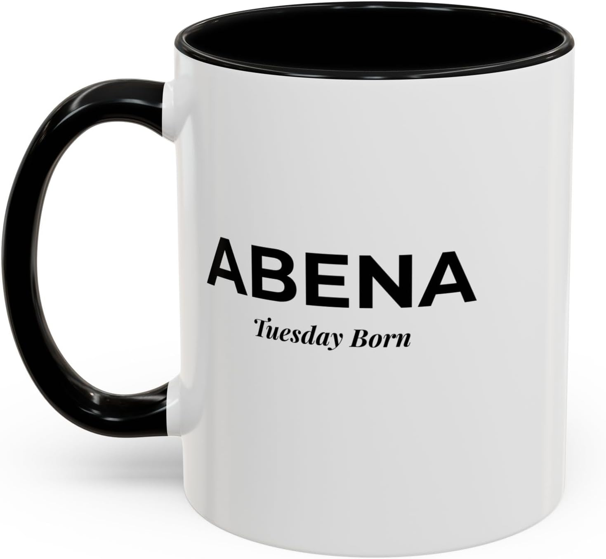

Abena Sankofa Mug
https://www.amazon.com/dp/B0H5BTRF98

Kwabena Sankofa Mug
https://www.amazon.com/dp/B0H5BR541V

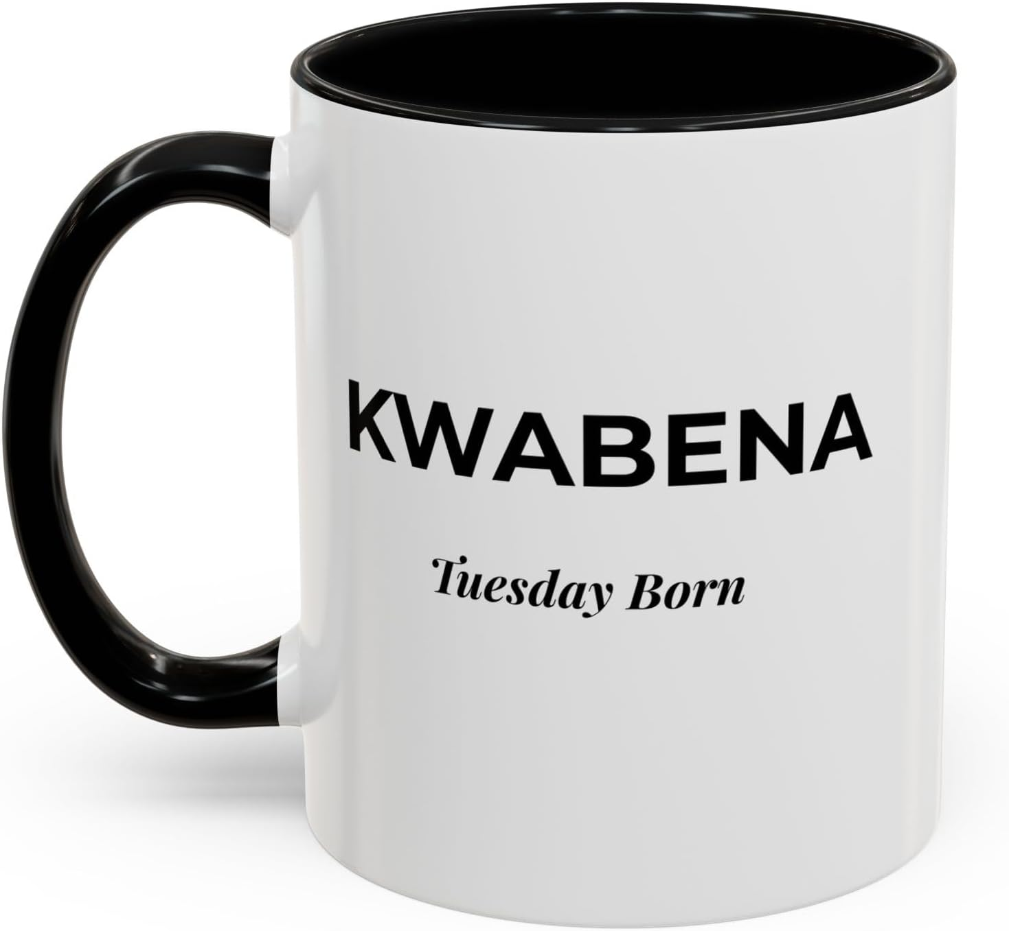

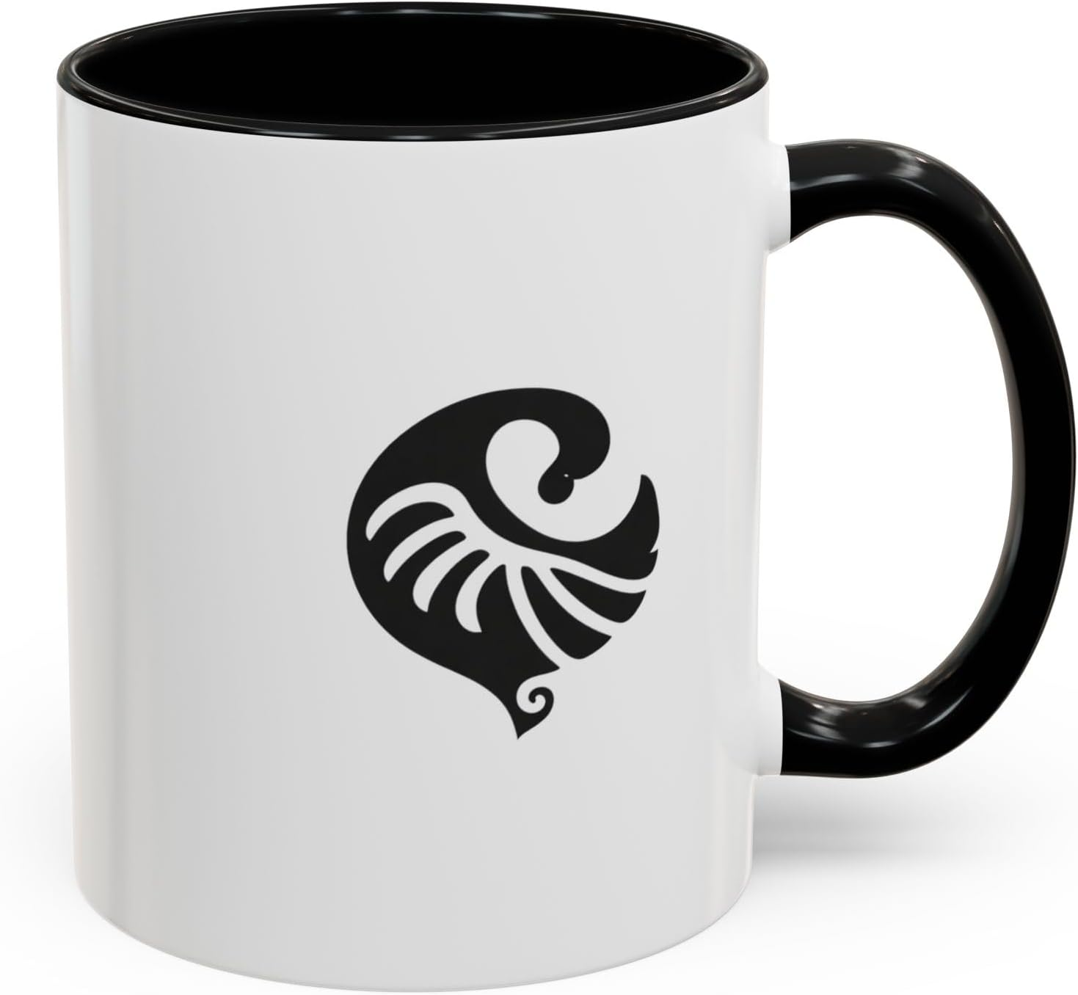
Kwabena Gye Nyame Mug
https://www.amazon.com/dp/B0H5BMG5X4
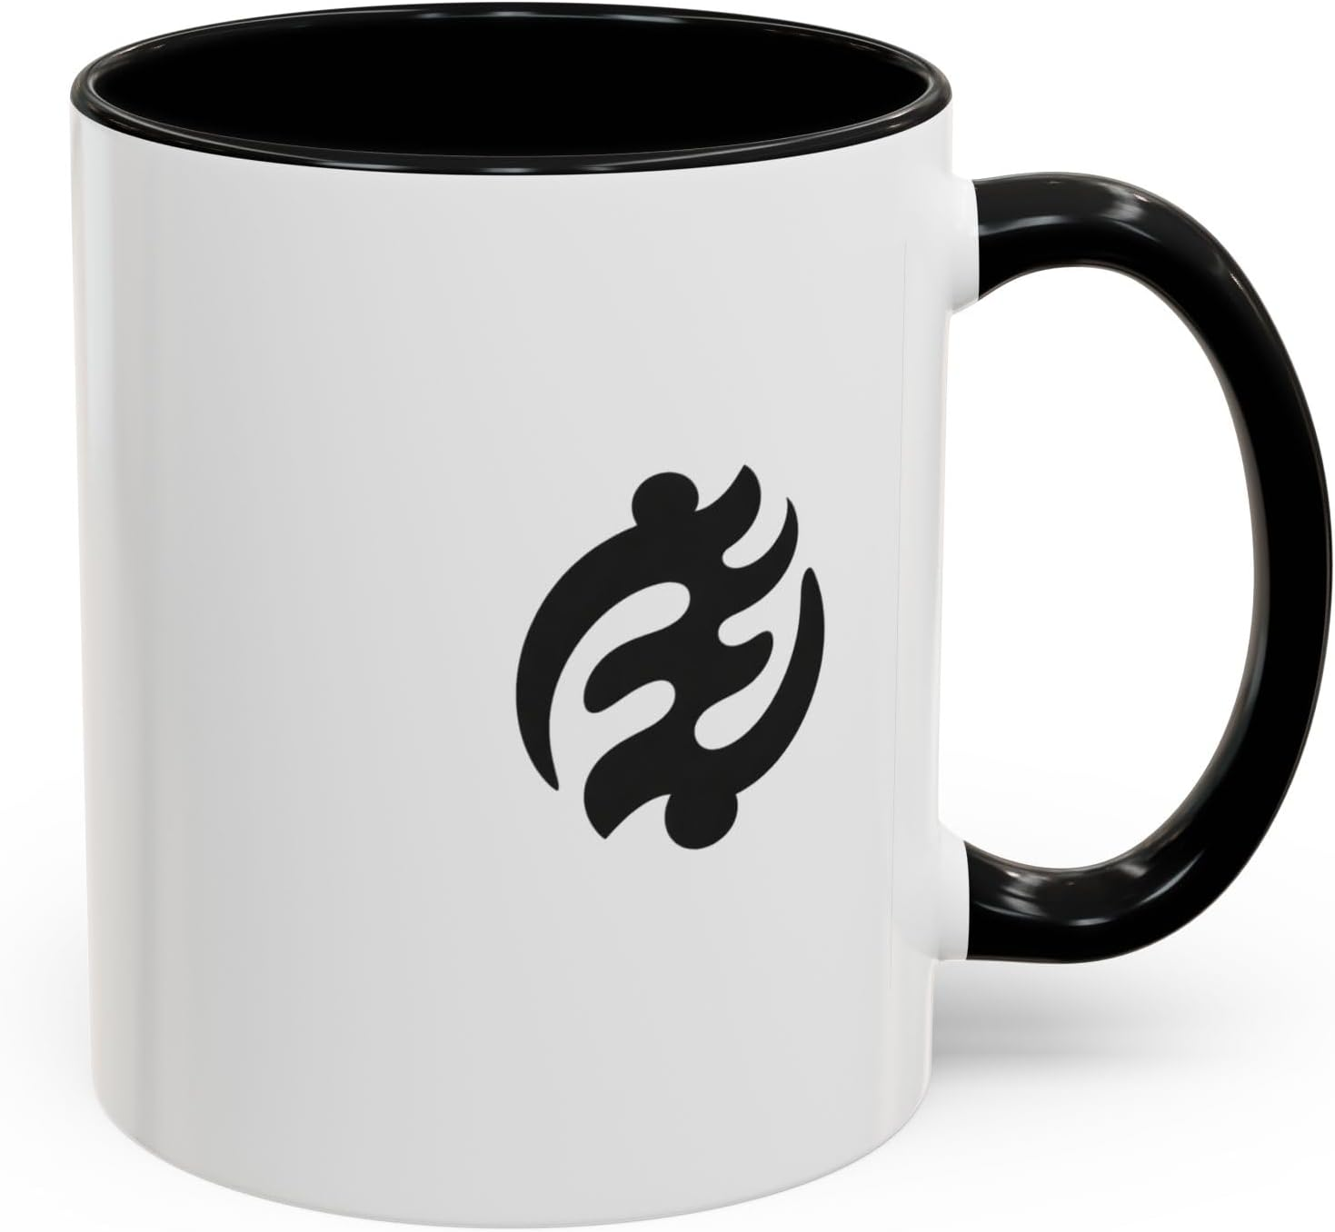

Kwabena Baby
https://www.amazon.com/dp/B0H5FN245C?th=1&psc=1
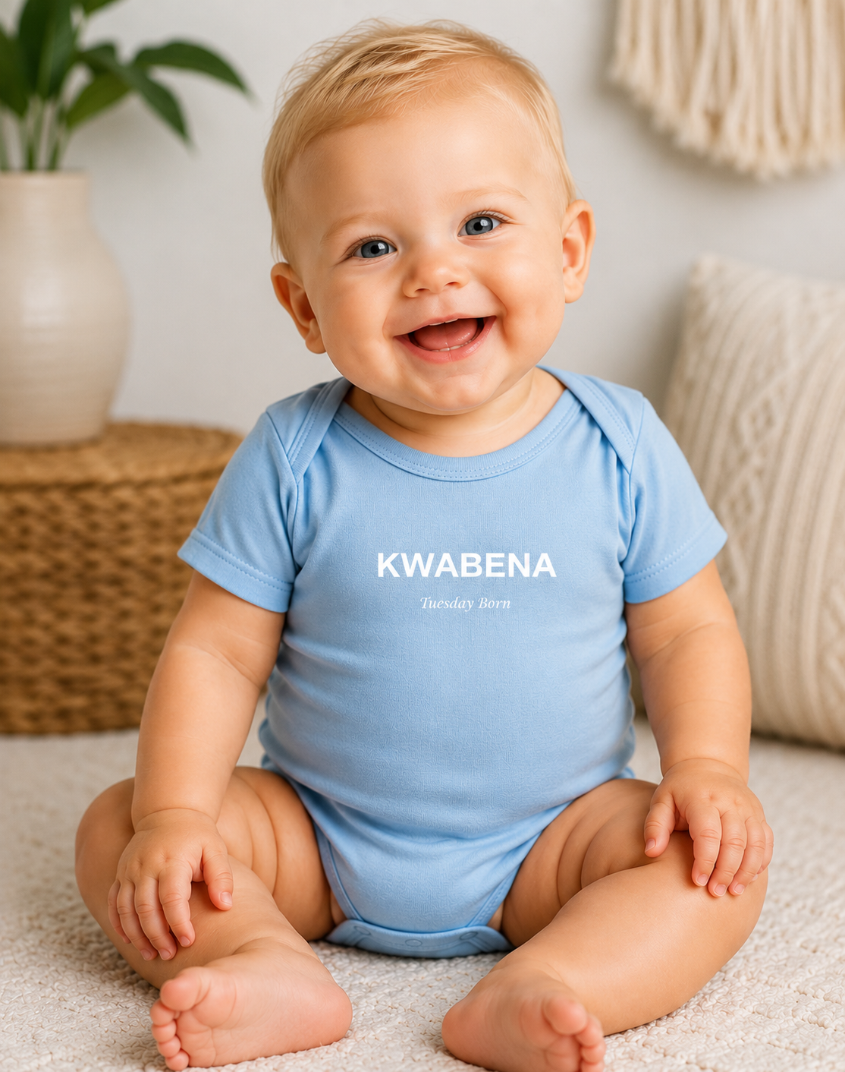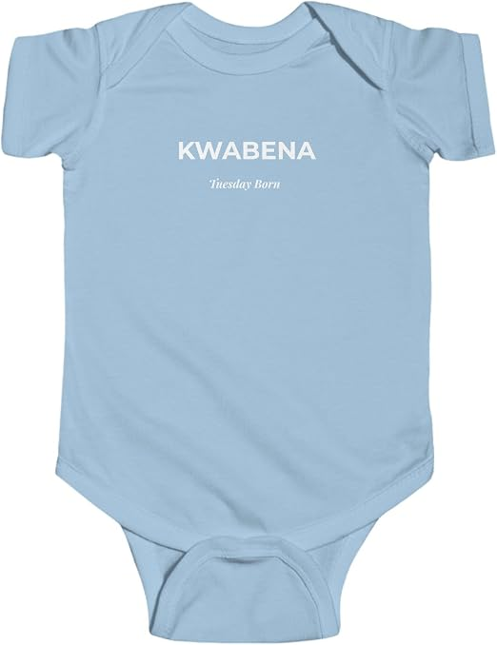

Abena Baby
https://www.amazon.com/dp/B0H5D5SZK4/ref=twister_B0H59SQ23W?_encoding=UTF8&th=1&psc=1

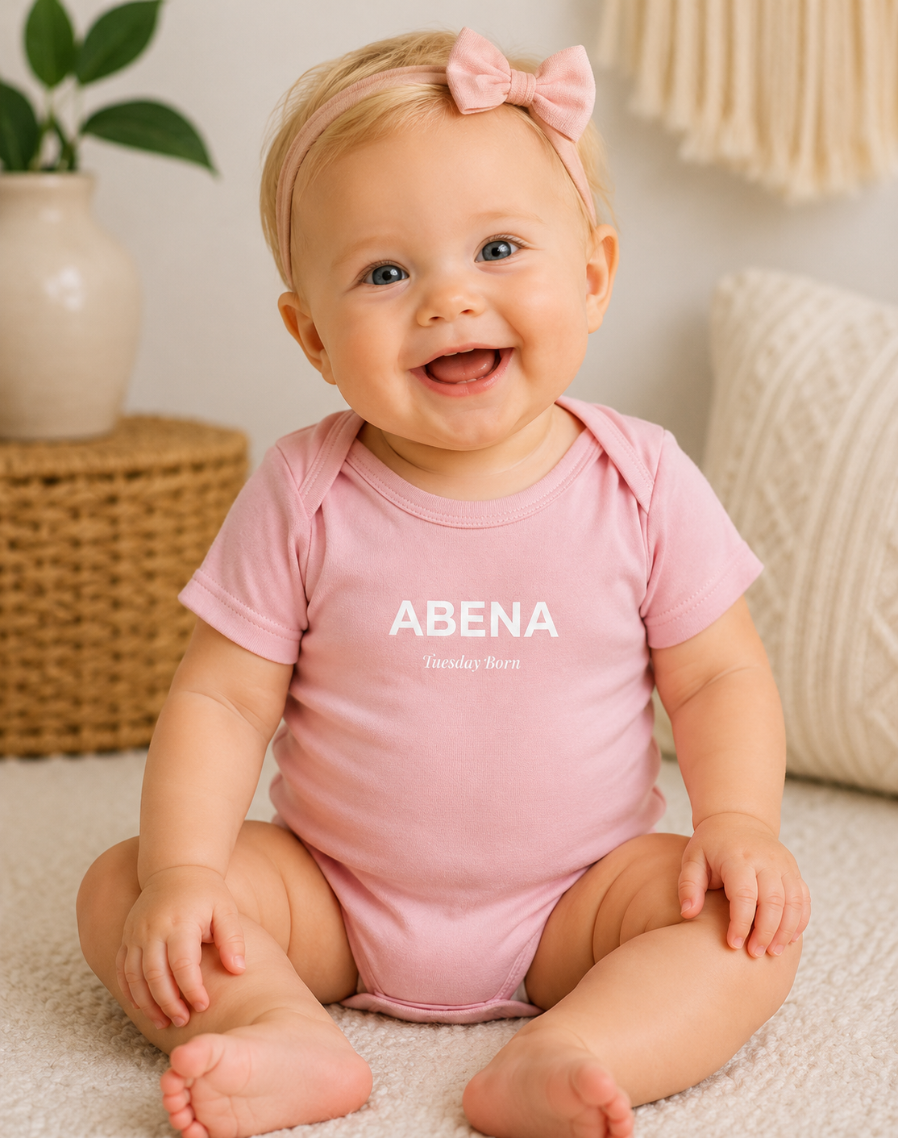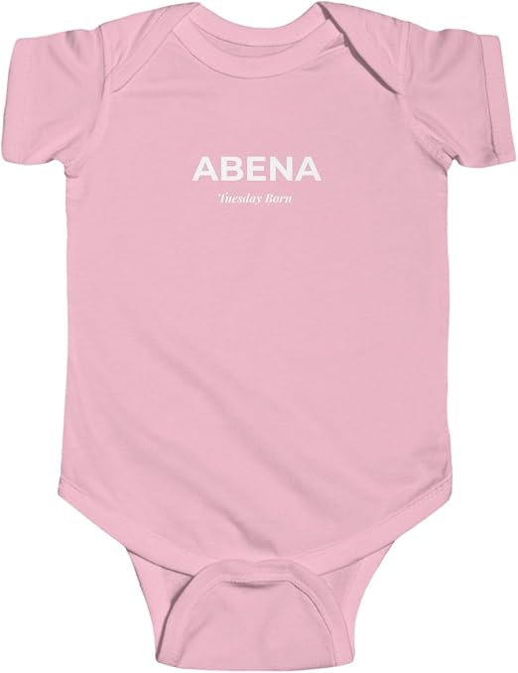
Kwabena Shirt Gye Nyame back
https://www.amazon.com/dp/B0H58N3JF6?th=1&psc=1
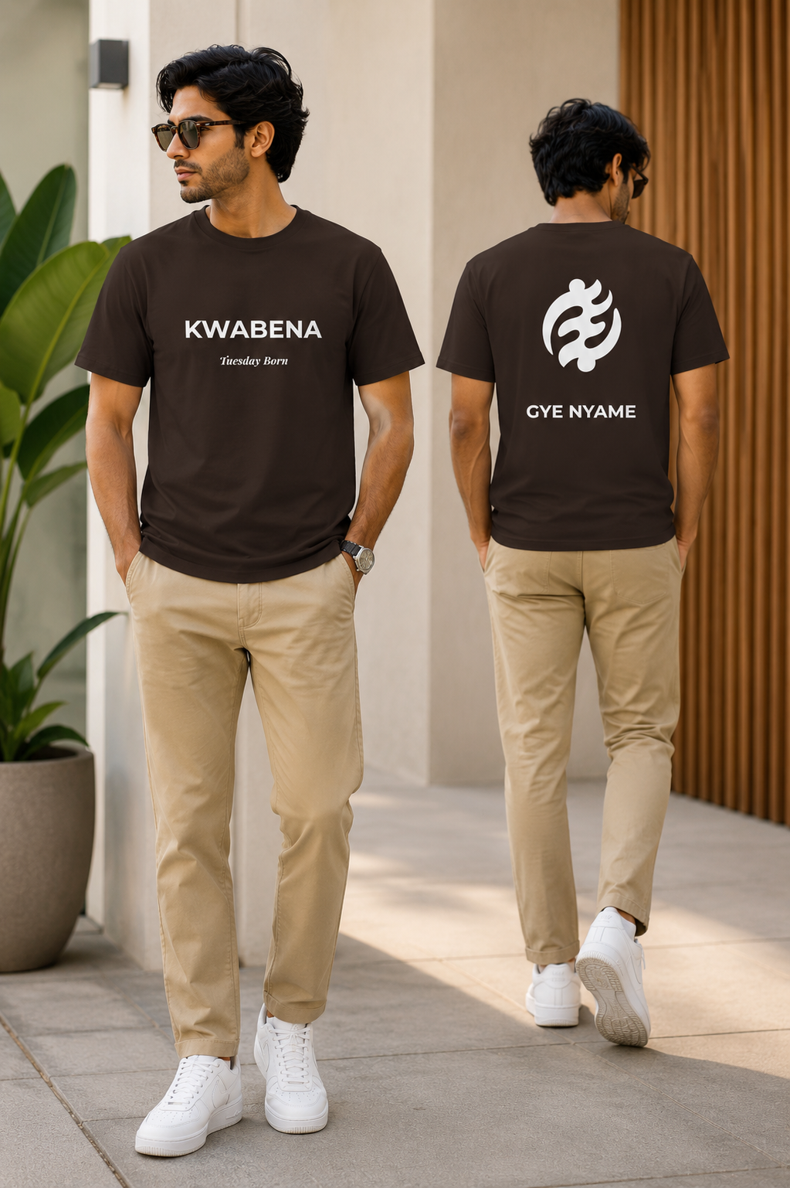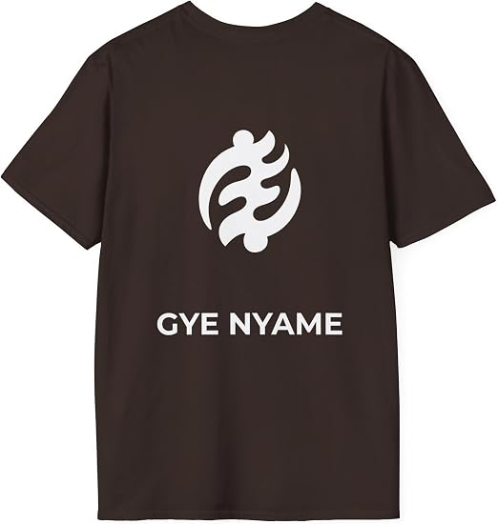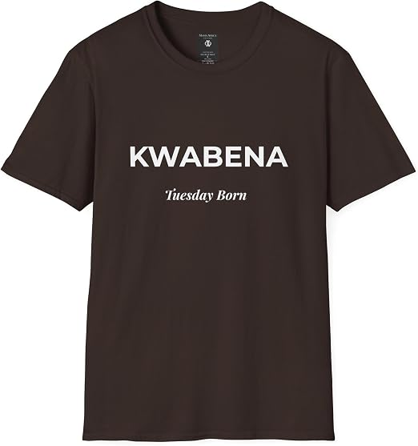
Kwabena Shirt Sankofa Back
https://www.amazon.com/dp/B0H3J8K7NX?th=1&psc=1
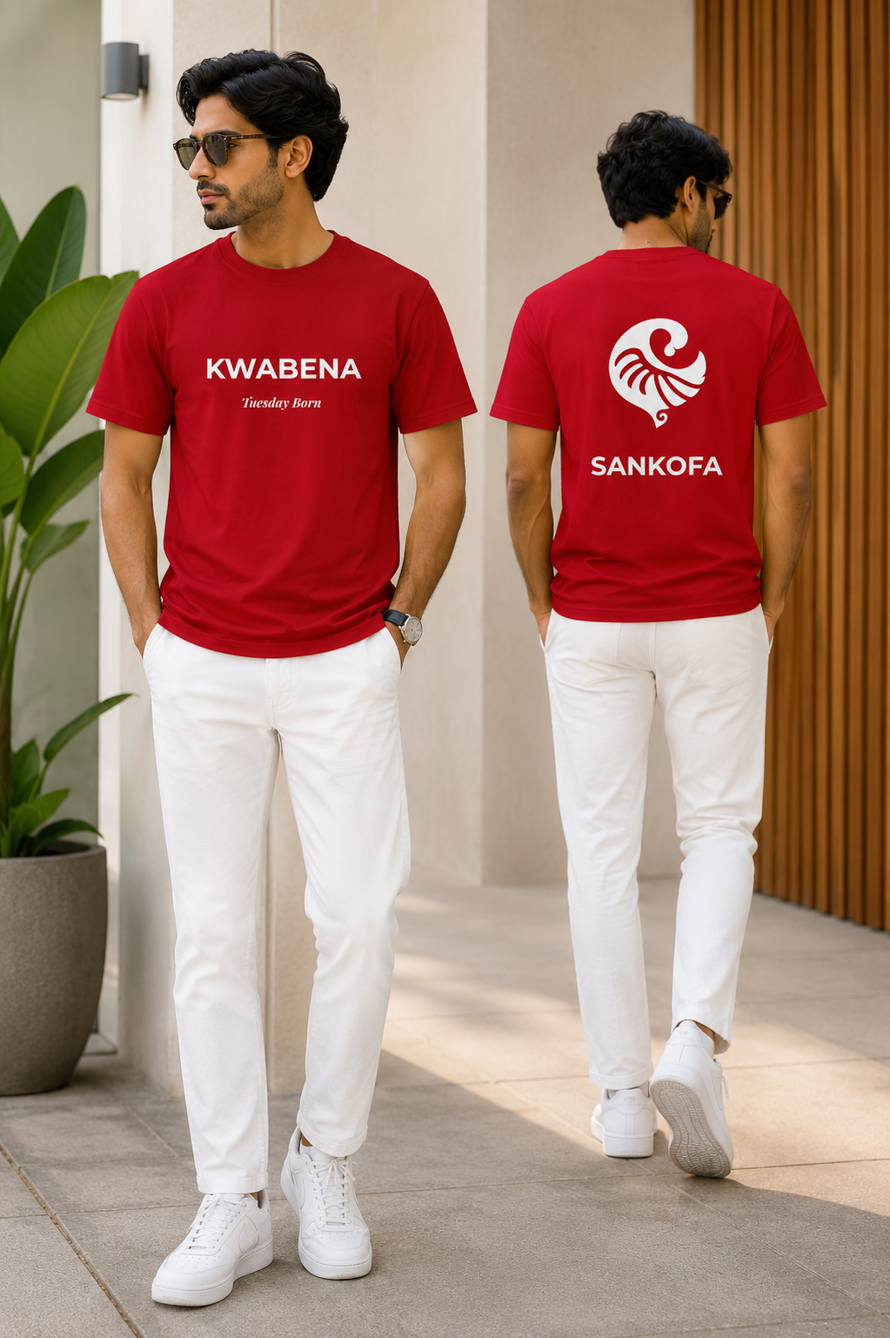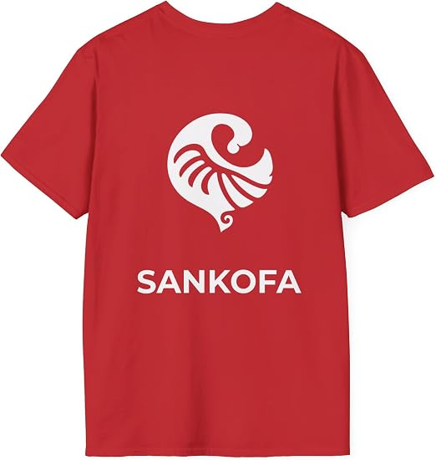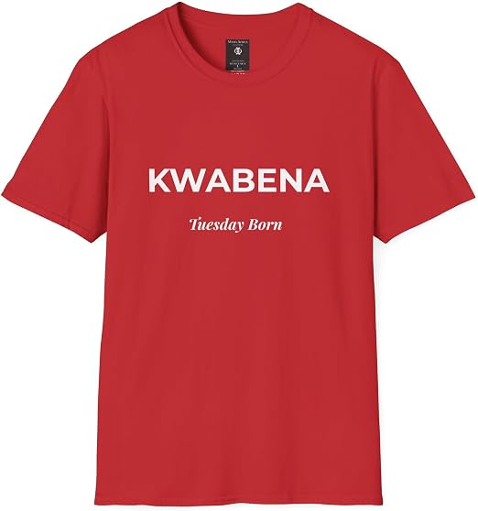

Abena Shirt Sankofa Back
https://www.amazon.com/dp/B0H3MPXCSF?th=1&psc=1

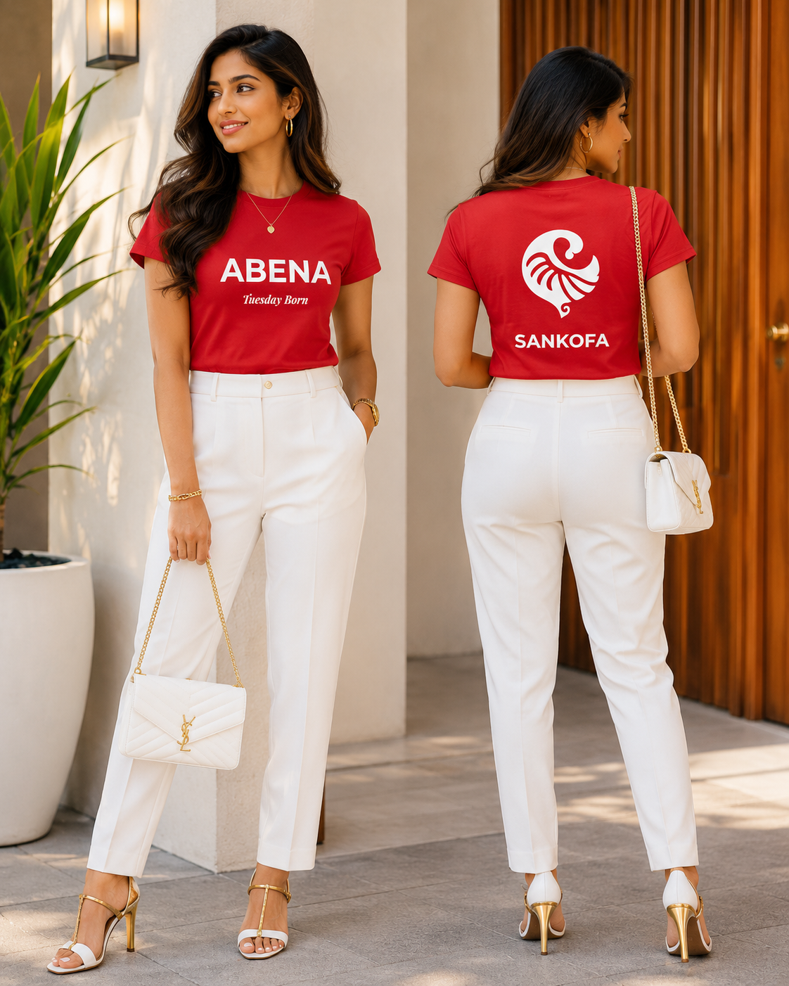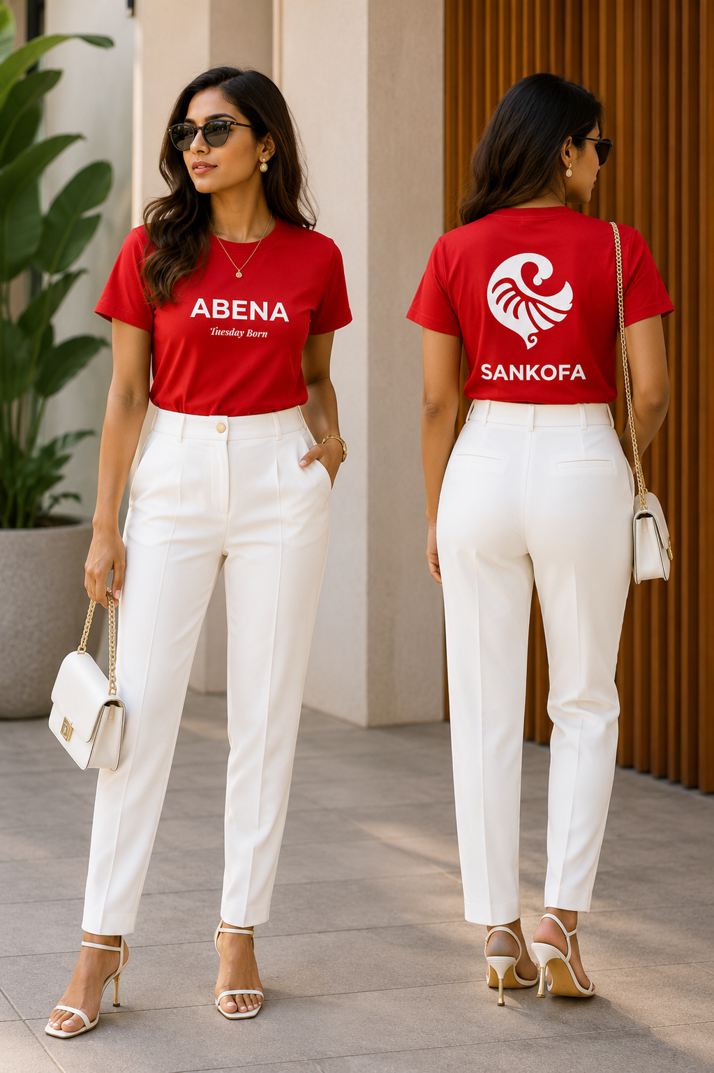
Abena Gye Nyame Back
https://www.amazon.com/dp/B0H3MVVT3V?th=1&psc=1
